

**K. J. Somaiya College of Engineering, Mumbai-77** (Somaiya Vidyavihar University)

**Name: Chandana Ramesh Galgali**

**Batch: P3-3 Roll No.: 16010422234**

**Experiment / ~~assignment~~ / ~~tutorial~~ No. 1**

**Grade: AA / AB / BB / BC / CC / CD /DD**

**Signature of the Staff In-charge with date**

| **TITLE: a.** C Program to find perimeter/circumference and area of various geometric shapes.  **b.** C program to calculate EMI (Equated Monthly Installment) of loan amount if principal, rate of interest and time in years is given by the user.  (E = (P.r.(1+r)n) / ((1+r)n– 1) |
| --- |

**Books/ Journals/ Websites referred:**

1. Programming in C, second edition, Pradeep Dey and Manas Ghosh, Oxford University Press.

2. Programming in ANSI C, fifth edition, E Balagurusamy, Tata McGraw Hill.

3. Introduction to programming and problem solving , G. Michael Schneider ,Wiley India edition.

4. **http://cse.iitkgp.ac.in/~rkumar/pds-vlab/**

**_____________________________________________________________________ Problem Definition:**

a. Ask user to enter the input values to compute perimeter/circumference and area of the given shapes. Put the values in the given formula and print the outcome given by the formula on the screen.

b. Ask user to enter the input values such as principal amount, rate of interest, number of years to compute EMI. Put the values in the given formula and print the outcome given by the formula on the screen.

**Department of Science and Humanities**

Page No PIC Sem I/August-December 2022-23



**K. J. Somaiya College of Engineering, Mumbai-77** (Somaiya Vidyavihar University)

**Flowchart: ( for both the sections a and b separately)**

For section (a):



For section (b):



**Department of Science and Humanities**

Page No PIC Sem I/August-December 2022-23



**K. J. Somaiya College of Engineering, Mumbai-77** (Somaiya Vidyavihar University)

**Implementation details:**

For section (a):

#include<stdio.h>

void main()

{

float s,l,b,r,a;

printf("Enter the length of side of the square(put 0 if N.A.): ");

scanf("%f",&s);

printf("\nEnter the length of the rectangle(put 0 if N.A.): ");

scanf("%f",&l);

printf("\nEnter the breadth of the rectangle(put 0 if N.A.): ");

scanf("%f",&b);

printf("\nEnter the length of radius of the circle(put 0 if N.A.): ");

scanf("%f",&r);

printf("\nEnter the length of side of the equilateral triangle(put 0 if N.A.): ");

scanf("%f",&a);

printf("\n \n Perimeter of the square: %f",4*s);

printf("\n Perimeter of the rectangle: %f",2*(l+b));

printf("\n Circumference of the circle : %f",2*3.14*r);

printf("\n Perimeter of the equilateral triangle: %f",3*a);

printf("\n \n Area of the square: %f",s*s);

printf("\n Area of the rectangle: %f",l*b);

printf("\n Area of the circle : %f",3.14*r*r);

printf("\n Area of the equilateral triangle: %f",0.433*a*a);

}

For section (b):

#include<stdio.h>

#include<math.h>

void main()

{

float p,r,ROI,EMI;

int n;

printf("Enter the value of the principal amount: ");

scanf("%f",&p);

printf("\nEnter the value of the Rate of Interest per annum: ");

scanf("%f",&ROI);

printf("\nEnter the number of months: ");

scanf("%d",&n);

r=ROI/(12*100);

printf("\n\nMonthly EMI: %f",EMI=(p*r*pow(1+r,n))/(pow(1+r,n)-1));

}

**Department of Science and Humanities**

Page No PIC Sem I/August-December 2022-23



**K. J. Somaiya College of Engineering, Mumbai-77** (Somaiya Vidyavihar University)

**Output(s):**

For section (a):

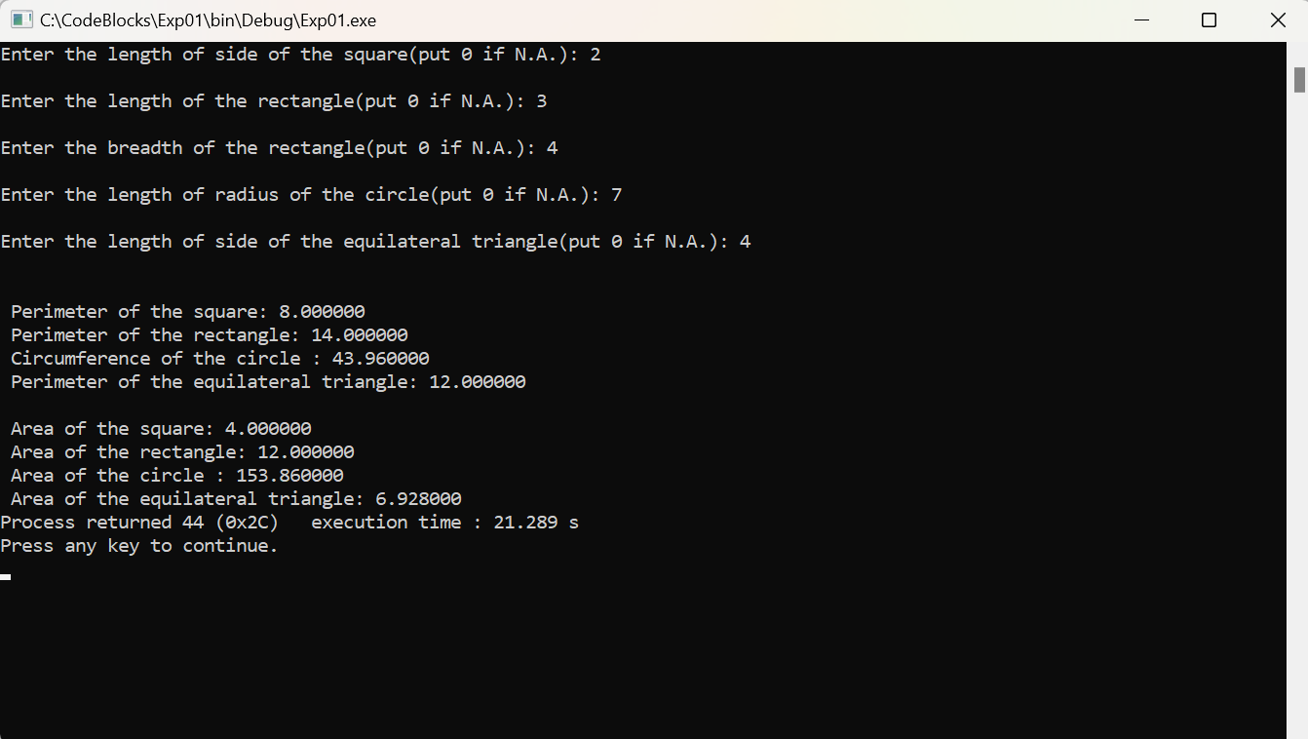

For section (b):

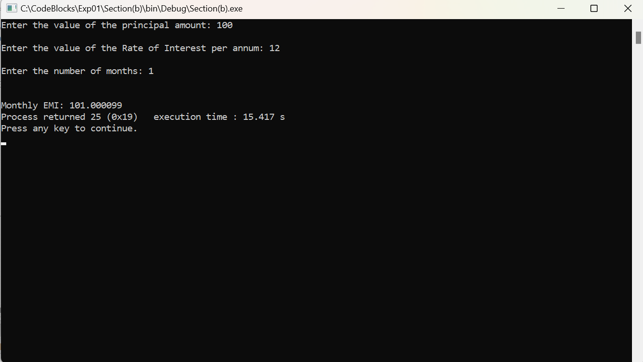

**Conclusion:** In section (a), the perimeter and area of a square, rectangle, circle and an equilateral triangle were calculated correctly, after taking the required input from the user. In section (b), early monthly installment(EMI) was correctly calculated after the required values were inputted by the user.

**Post Lab Descriptive Questions**

**1. What is a ‘problem definition’?**

**Ans:** A problem definition is compilation of logic in the form of general flow charts and logic diagrams which gives a clear explanation of the problem to the programmer and presents it in a way that all requirements involved in the run are presented.

**2. What is a flowchart? What are the standard symbols used to draw a flowchart? Explain in brief.**

**Ans:** Flowchart is a diagrammatic representation of a sequence of logical steps of a program. Flowcharts use simple geometric shapes to depict processes and arrows to show relationships and process/data flow.

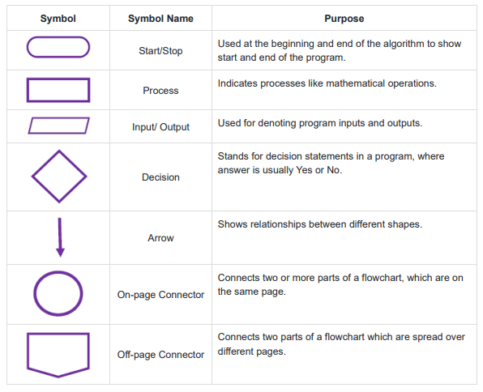

* A flowchart can have only one start and one stop symbol.
* On-page connectors are referenced using numbers.
* Off-page connectors are referenced using alphabets.
* General flow of a process is from top to bottom or left to right.
* Arrows should not cross each other.

**Date: _____________ Signature of faculty in-charge**

**Department of Science and Humanities**

Page No PIC Sem I/August-December 2022-23